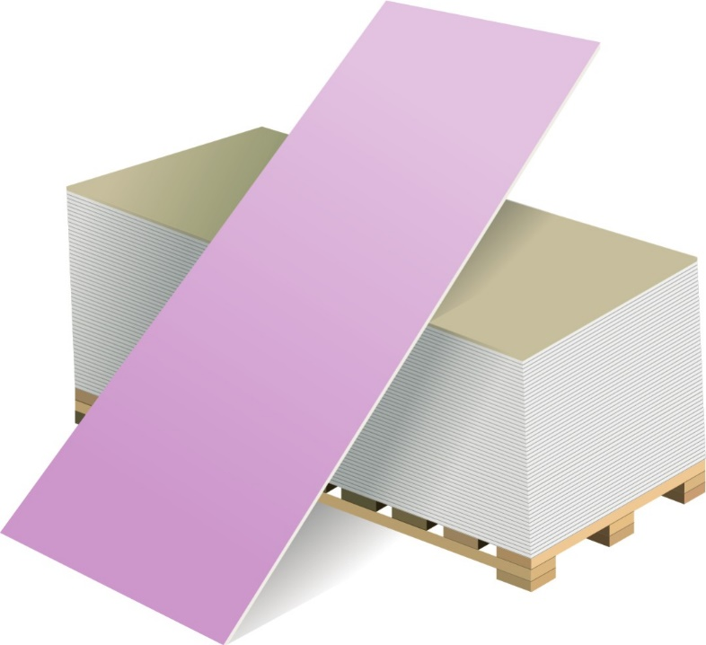
www.volma.ru EN

PLASTERBOARDS TYPE DF, DFH2 EN 520

Product description Plasterboards
Board type DF - EN 520 Board type DFH2 – EN 520
Gypsum ﬁre resistant plasterboard "VOLMA" is produced according to EN 520. These are boards consisting of a gypsum core reinforced by ﬁberglass with special additives and sturdy cardboard glued on the both sides. Longitudinal edges are seamed with cardboard.
Transverse edges - just cut.
Cardboard colour – pink. Marking stamp on the back side of the board – red.
Dimensions, Gypsum ﬁberboard type DF, DFH2
12.5 х 1200 х 2000 mm
12.5 х 1200 х 2500 mm
12.5 х 1200 х 2600 mm
12.5 х 1200 х 3000 mm
Storage conditions:
- On wooden blocks or pallets
- On spacers made of gypsum ﬁberboard
Application:
- Wall partitions with improved ﬁre resistance;
- Interior dry-lining;
- Hung ceiling

Depending on the properties and application of plates they are divided into the following types:
Fire resistant board with the improved open ﬂame resistance, is used for interior decoration of buildings and premises with dry, normal and humid humidity conditions and increased ﬁre hazard.
Moisture and ﬁre resistant board with the decreased water absorption and high open ﬂame resistance. It is used for interior decoration of buildings and premises with dry and normal humidity conditions and increased ﬁre hazard.

Shape of longitudinal edge:
Square edge (SE) Tapered edge (TE) Half-round tapered edge (HRTE)

Deviation in dimensions according to EN 520 Width +0/-4mm, Length +0/-5mm, Thickness +0,5/-0,5mm.

TECHNICAL DATA
PLASTERBOARDS TYPE DF, DFH2 EN 520

Regulatory document | EN 520 | Plasterboards type DF, DFH2
Material class | EN 13501-1 | A2-s1, d0 (B)
Density | ≥ 700 | kg/m³
Dry weight | ≥ 8,9 | kg/m²

Tensile strength | EN 520 | ≥ 550 (parallel to the direction of production)  ≥ 210 (perpendicular to the direction of production) | N

Thermal-conductivity coeﬃcient | EN 12524 | λА =0,19; λБ =0,21 | (watt /m·⁰C)
U-value |  | SА= 3,34; SБ=3,66 | (watt/m²·⁰C)
Water vapour diﬀusion resistance factor µ | EN 12524 | Dry: 10  Wet: 4
Type DFH2 Water absorption (general) for 2 h. under water storage |  | ≤10 | % by weight
Crystal water content in the core |  | appr. 16–20 | %
Thermal eﬀect border (long-term) |  | 50 | °С
рН-value |  | 6-9 | ---
Air permeability | EN 520 | 1,4 10⁻⁶ | m³/(m² with Pa)
Metal plasterboard profile | EN 14195 | DIN 18182-1: 2015-11

